Plastic Free Events/Markets
Template pre-event letter to stall holders and vendors

(For the use of Plastic Free Noosa member events/markets)

Information should be provided from the start to your vendors explaining what you're doing, why you're doing it and how they can participate. You may encounter resistance, particularly if there is an additional cost. A pre-event letter to vendors is a great way to provide information and gain their support. You can also include with a link to our Vendor Guidelines.

Words of encouragement and support also work well. Ensure your vendors understand that successful composting requires all to be involved and that they are key players. Work with your vendors and be on hand to help them with the transition. If any vendors sign up as a Plastic Free Noosa member, we can come out and work with them personally, please encourage them to do so.

This document provides you some suggested wording which you can choose and alter to suit your event. We’ve included actions for both plastic free and zero waste – choose accordingly.

ATTENTION ALL STALLHOLDERS AND VENDORS
[Event Name] has joined Plastic Free Noosa and is a Plastic Free and Zero Waste event.

The [Event name] to be held on [Event Date], will place a large emphasis on environmental issues, particularly through eliminating single-use plastic and reducing waste. We recognise the important contribution our stallholder/vendors make, and we encourage you to see this as an important step towards a shared sustainable future.

Packaging

To help make this successful, all stallholders/ vendors taking part in the [Event Name] are required in event policy to use only reusable or approved compostable products and packaging. (We suggest limiting vendor choices as part of your event policy. There is too much opportunity out there for vendors to make bad choices). As we will be composting our food waste and packaging, it is important to minimise contamination and for this reason we reserve the right to ask vendors who do not comply to leave the event.

A set of vendor guidelines (download these from our website HERE – there are 3 guidelines which cover food vendors, non-food vendors and produce vendors which are found in the resources section of this page) and approved product catalogues (download these from HERE) are attached (or use links instead) to help you. You are required to choose compostable items contained only within these catalogues. If you would like to locate suppliers that stock these products, please go to www.plasticfreenoosa.org/suppliers

Vendors are also required to eliminate soft plastic in line with attached vendor guidelines. Should you require any assistance or have any additional requirements, please contact [Event Organiser].

This event will not allow the sale or giveaway of plastic water bottles. A water station will be provided and patrons are able to use reusable bottles. You are permitted to sell reusable bottles. (put in here any other information, such as if you have sourced water bottles for vendors to sell).

To assist with a successful Plastic Free/Zero Waste event, we will also be providing the following:
- Reusable food-ware (cups, plates, cutlery) for vendors to use.
- A wash up station which will be staffed by volunteers. They will collect used food-ware, wash, dry and restock vendors.
- A condiments station which will contain sauces, salt, sugar and napkins. You are not required to provide these separately.
- A reusable cup system which patrons will be able to access through a deposit and refund system. Cups will be obtained from the bar/cup station. You are able to provide drinks ONLY to patrons who have one of these cups.

This event will not allow the sale or giveaway of helium balloons. Please source plastic free alternatives. If you need assistance on alternatives, please contact [Event Organiser].

Waste

There will be [insert number] different types of waste streams at the venue:
- Mixed Recycling
- Compostable/ organics
- General waste
- Container collections under the Container Refund Scheme

It is important that you put only the correct types of material in each waste stream. Contamination can result in whole loads going to general waste which will undermine our waste policy. Please see the list below to determine correct materials for each stream (adjust to suit).

Compostable at this event | 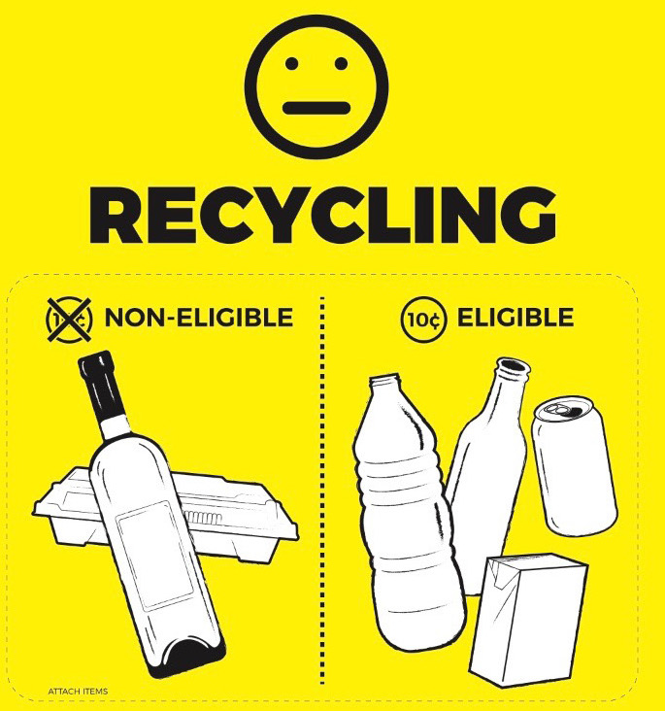  Recyclable at this Event | 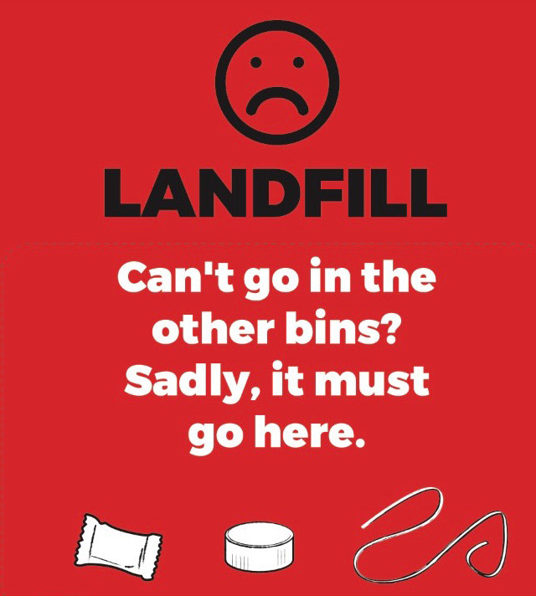  General Waste at this Event | Container Collection  (eligible containers)
- Foodware & packaging  - Food | - Plain milk bottles  - Wine bottles  - Pure spirit bottles  - Steel cans | - Polystyrene foam*  - Soft Plastics*  - Waxed cardboard | - Aluminium cans  - Plastic bottles  - Glass bottles  - Poppers  - Liquid Paperboard (e.g flavoured milk cartons

During the event we will have ‘Waste Warriors’ positioned at front-of-house bin stations to help the public determine what bin to use for their particular item. Back of house bins will not be manned, however they will be well signed. Please only use assigned back-of house bins for your needs (not front-of-house bins).

As well as the above there will be facilities provided back-of-house for vendors to enable collection of cardboard. All clean cardboard containers must be flattened before placing them in the bales. Remove sticky tape and plastic wrap. This year we will also be collecting any back-of-house soft plastic wrapping to take for recycling. Only soft (scrunch-able) plastic can be placed in this bin.

At the event, you will be issued with a site map so you can see where your nearest bin stations are placed. Please ensure you share this information with your staff so that they also know where to take their waste to.

We look forward to having you on board this year to assist us in managing the waste generated from this event and diverting as much as we can from landfill. We can make a difference in our local environment by working together and managing our waste wisely.

Should you require any assistance, clarification, or have any additional requirements that may not be met under the event details outlined above please contact the [Event Organiser] on [Phone No.]

Thank you
[Name]
[Event Coordinator]

Attachments
Ensure to include your event policy, vendor guidelines and compostable-only product catalogues (or provide links to these).

